CONTEXT DIAGRAM

DATA FLOW DIAGRAM

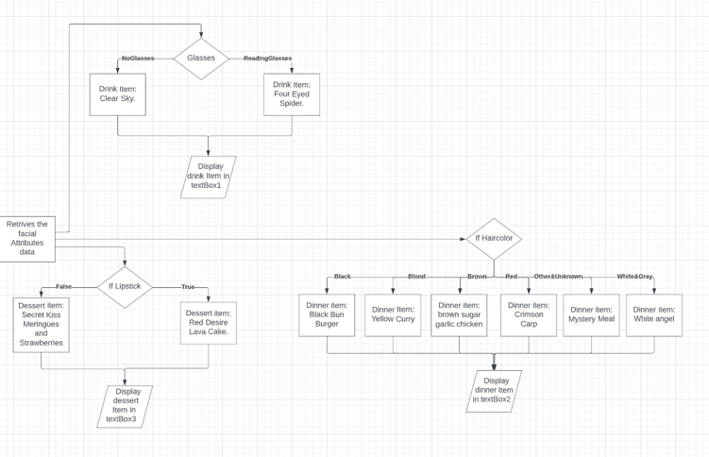ALGORITHM FLOWCHART

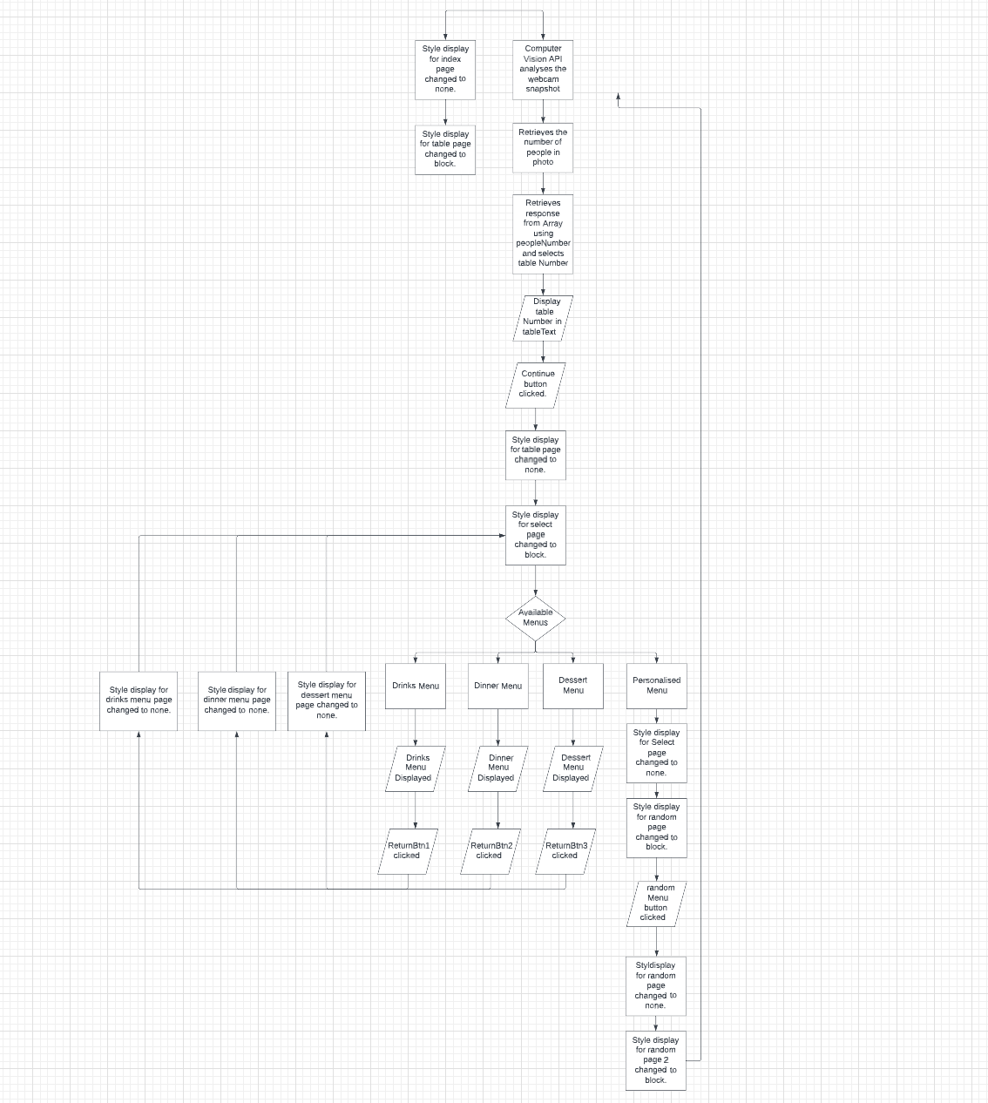

*Note: The website I was using was not allowing me to go past a certain number of boxes so everything here is pasted together to look like one thing.

STRUCTURE CHART  
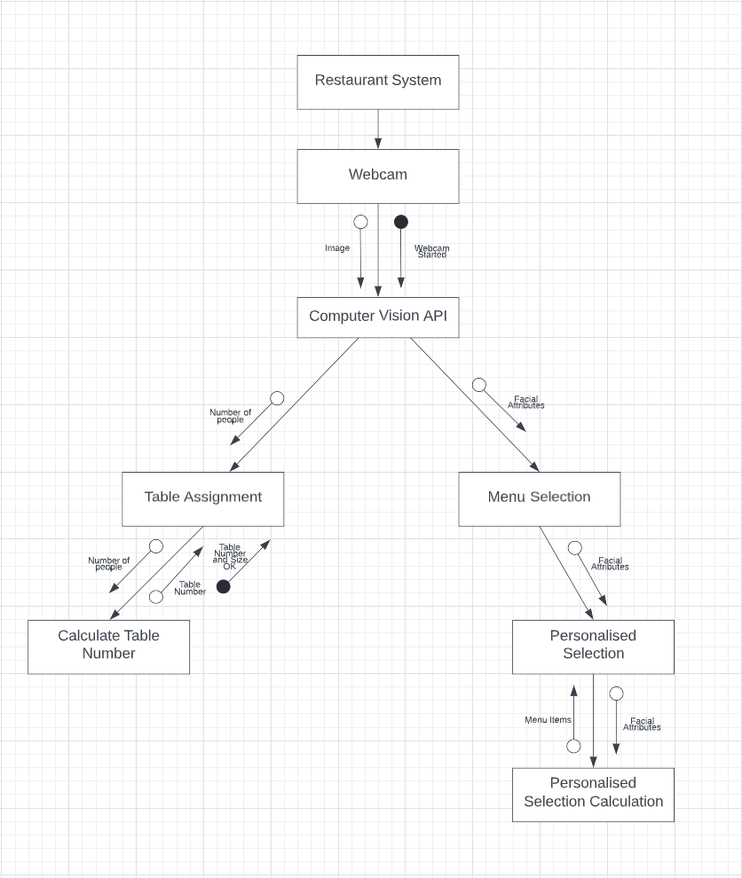

IPO CHART

|  |  |  |
| --- | --- | --- |
| Input | Process | Output |
| Function: startTime | gets the hours, minutes, and seconds and displays them in the clock div html. | Displays the hours, minutes, and seconds on the start screen. |
| Function: checkTime | checks the minutes and seconds and adds a 0 if the integer is below 10 | 0 is displayed in front of minutes and seconds lower in value than 10 |
| Function: WebcamStart. | Connects to the device’s webcam when function is called and starts the webcam. | Webcam video is displayed in the video section with the id= “webcam”  If webcam starts then console.log (”webcam started!”) If there’s an error then console.log (”error”) |
| When takePhoto button is clicked. | Stops the webcam. Creates a variable called picture and stores the webcam snapshot in it.  Changes the style display of the webcam video section to ‘none’. | Webcam video is hidden and is not displayed anymore.  The snapshot is displayed in the canvas section in place of the webcam. |
| When submit button is clicked. | Analyses the facial attributes of all people present in the picture / canvas.  Changes the style display of the index page to none and the table page to block | Image Analysation Data  The Index Page containing the take photo and submit buttons along with the canvas are hidden and not displayed. The table Page is instead displayed. |
| Image Analysation Data | Retrieves the data.length which is stored in the PeopleNo variable. Uses PeopleNo integer to choose a tableNumber array, and then a response from the selected array using Math.random.  Retrieves the faceAttributes data such as if people are wearing lipstick or glasses and their hair colours. | Table Number is displayed. console.log(”Number of people present is” + peopleNo”)  Lipstick information is stored in variable lipstick Glasses information is stored in variable glasses Hair color information is storied in variable haircolor |
| When contBtn button is clicked. | Changes the style display of the table page to none and the select page to block. | Displays the select Page with the four menu buttons. |
| When drinksBtn button is clicked. | Changes the style display of the select page to none and the drinksMenu page to block. | Displays the drinks Menu and the returnBtn1 button. |
| When returnBtn1 button is clicked. | Changes the style display of the drinksMenu page to none and the select page to block. | Displays the select Page again with the four menu buttons. |
| When dinnerBtn button is clicked. | Changes the style display of the select page to none and the dinnerMenu page to block. | Displays the dinner menu and the returnBtn2 button. |
| When returnBtn2 button is clicked. | Changes the style display of the dinnerMenu page to none and the select page to block. | Displays the select Page again. |
| When dessertBtn button is clicked. | Changes the style display of the select page to none and the dessertMenu page to block. | Displays the dessert menu and the returnBtn3 button. |
| When returnBtn3 button is clicked. | Changes the style display of the dessertMenu page to none and the select page to block. | Displays the select Page again. |
| When randomBtn button is clicked. | Changes the style display of the select page to none and the random page to block. | Displays the random page which informs the user of the personalised menu and how it works. |
| When randomMenubtn button is clicked. | Changes the style display of the random page to none and the random page 2 to block. | Displays the random / personalised menu page which contains textBox1, textBox2 and textBox3 which display the personalised menu items. |
| When returnBtn4 button is clicked. | Changes the style display of the random Page 2 page to none and the select page to block. | Displays the select Page again. |
| function: drinksText | Creates the variables drinksText; which calls the text from the drinks array and drinksImg; which calls the image from the drinks array when a certain number or parameter is given based on the variable glasses | The personalised menu drink item/s is displayed in textBox1. |
| function: dinnerText | Creates the variables dinnerText; which calls the text from the dinner array and dinnerImg; which calls the image from the dinner array when a certain number or parameter is given based on the variable haircolor | The personalised menu dinner item/s is displayed in textBox2. |
| function: dessertText | Creates the variables dessertText; which calls the text from the dessert array and dessertImg; which calls the image from the dessert array when a certain number or parameter is given based on the variable lipstick. | The personalised menu dessert item/s is displayed in textBox3. |
| Function:WebcamStop. | Connects to the device’s webcam when function is called and stops the webcam. | Webcam video is hidden from the user and is not displayed. If webcam stops then console.log(”webcam stopped :(.”) If there’s an error then console.log(”error”) |